**Database Management System (DBMS)**

* ■ Basically, a system for managing data
* ■ DBMS contains information about a particular enterprise (application)

● Collection of interrelated data

● Set of programs to access the data

● An environment that is both *convenient* and *efficient* to use

**■ Drawbacks of using file systems to store data:**

● Data redundancy and inconsistency

! Multiple file formats, duplication of information in different files

● Difficulty in accessing data

! Need to write a new program to carry out each new task

● Data isolation — multiple files and formats

● Integrity problems

! Integrity constraints (e.g. account balance > 0) become “buried” in program code rather than being stated explicitly

! Hard to add new constraints or change existing ones

* ■ Schema – the logical structure of the database

● Example: The database consists of information about a set of customers and accounts and the relationship between them)

● Analogous to type information of a variable in a program

● Physical schema: database design at the physical level

● Logical schema: database design at the logical level

* ■ Instance – the actual content of the database at a particular point in time

● Analogous to the current values of a set of variables

**Attribute Types**

■ The set of allowed values for each attribute is called the **domain** of the attribute

■ Attribute values are (normally) required to be **atomic**; that is, indivisible

* ■ The special value ***null*** is a member of every domain
* ■ The current values (**relation instance**) of a relation are specified by a table
* ■ An element ***t*** of ***r*** is a *tuple*, represented by a *row* in a table

**Keys**

* ■ Let K ⊆ R, R set of attributes of a relation schema
* ■ *K* is a **superkey** of *R* if values for *K* are sufficient to identify a unique tuple of each possible relation *r(R)*
* ● Example: {*ID*} and {ID,name} are both superkeys of *instructor.*
* ■ Superkey *K* is a **candidate key** if *K* is minimal
* ■ One of the candidate keys is selected to be the **primary key**.
* ■ **Foreign key** constraint: Value in one relation must appear in another
* ● **Referencing** relation ● **Referenced** relation

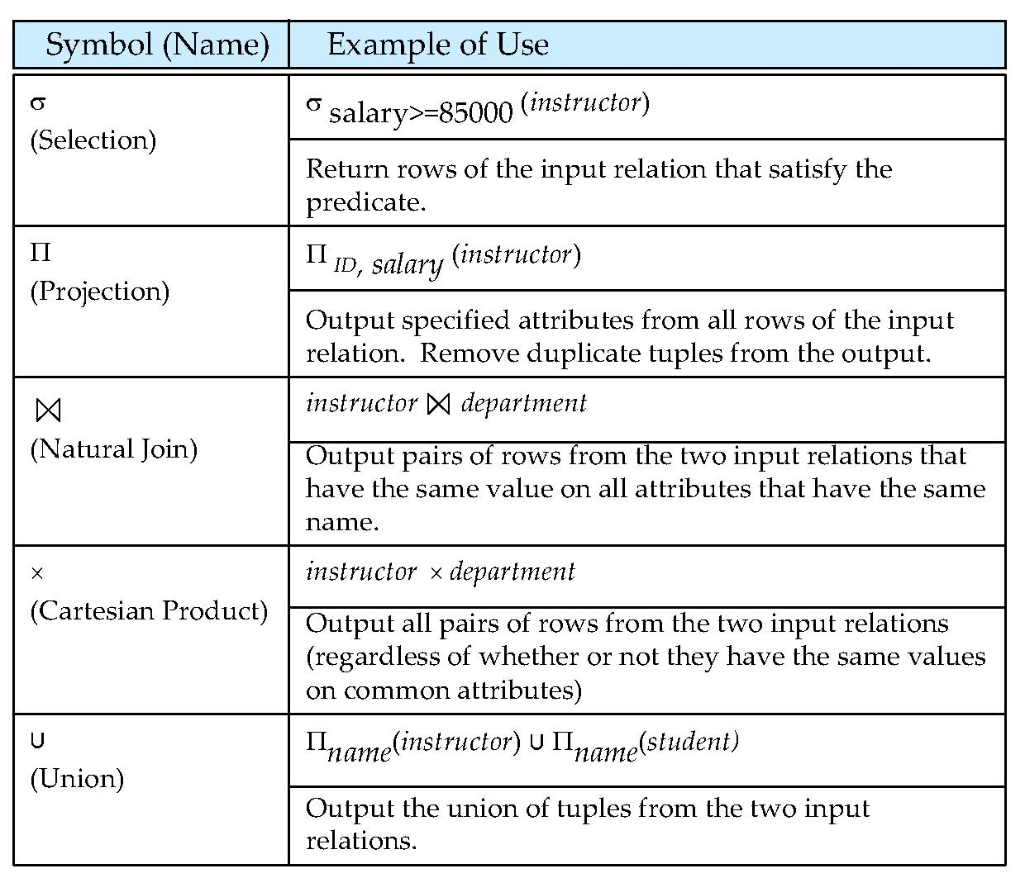

**Outer Join**

* ■ An extension of the join operation that avoids loss of information.
* ■ Computes the join and then adds tuples form one relation that does not match tuples in the other relation to the result of the join.
* ■ Uses *null* values:
* ● *null* signifies that the value is unknown or does not exist
* ● All comparisons involving *null* are (roughly speaking) **false** by definition.

**Null Values**

* ■ The result of any arithmetic expression involving *null* is *null.*
* ■ Aggregate functions simply ignore null values (as in SQL)
* ■ Comparisons with null values return the special truth value: *unknown*
* ● If *false* was used instead of *unknown*, then *not (A < 5)*  would not be equivalent to *A >= 5*
* ■ Three-valued logic using the truth value *unknown*:
* ● OR: (*unknown* **or** *true*) = *true*, (*unknown* **or** *false*) = *unknown*,
* (*unknown* **or** *unknown*) *= unknown*
* ● AND: (*true* **and** *unknown*) *= unknown,* (*false* **and** *unknown*) *= false,*  (*unknown* **and** *unknown*) *= unknown*
* ● NOT*:* (**not** *unknown*) *= unknown*

● In SQL “*P* **is unknown**” evaluates to true if predicate *P* evaluates to *unknown*

■ Result of select predicate is treated as *false* if it evaluates to *unknown*

**create table**

**create table** *instructor* ( *ID* **char**(5),

*name* **varchar**(20) **not null,**

*dept_name* **varchar**(20),

*salary* **numeric**(8,2),

**primary key** (*ID*),

**foreign key** *(dept_name*) **references** *department)*

//primary key declaration on an attribute automatically ensures not null

● **insert into** *instructor* **values** (‘10211’, ’Smith’, ’Biology’, 66000);

* ● **alter table** *r* **add** *A D*
* ! where *A* is the name of the attribute to be added to relation *r* and *D* is the domain of *A.*
* ! All tuples in the relation are assigned *null* as the value for the new attribute.
* ● **alter table** *r* **drop** *A*
* ! where *A* is the name of an attribute of relation *r*
* ! Dropping of attributes not supported by many databases.

**The select Clause**

* ■ To force the elimination of duplicates, insert the keyword **distinct** after select**.**

**select distinct** *dept_name*

**from** *instructor*

■ The keyword **all** specifies that duplicates not be removed.

**select all** *dept_name*

**from** *instructor*

■ An asterisk in the select clause denotes“all attributes”

**select** *

**from** *instructor*

**The from Clause**

■ The **from** clause lists the relations involved in the query

● Corresponds to the Cartesian product operation of the relational algebra.

**select**\*

**from** *instructor, teaches*

● generates every possible instructor – teaches pair, with all attributes from both relations.

**The where Clause**

■ The **where** clause specifies conditions that the result must satisfy

● Corresponds to the selection predicate of the relational algebra.

To find all instructors in Comp. Sci. dept with salary > 80000

**select** *name* **from** *instructor*

**where** *dept_name =* ‘Comp. Sci.' **and** *salary* > 80000

Comparison results can be combined using logical connectives **and, or,** and **not.**

**The Rename Operation**

■ The SQL allows renaming relations and attributes using the **as** clause:

*old-name* **as** *new-name*

* ● **select** *ID, name, salary/12* **as** *monthly_salary*

**from** *instructor*

* ■ Find the names of all instructors who have a higher salary than some instructor in ‘Comp. Sci’.

● **select distinct** *T. name***from** *instructor* **as** *T, instructor* **as** *S*

**where** *T.salary > S.salary* **and** *S.dept_name =* ‘*Comp. Sci.*’

**String Operations**

● percent (%). The % character matches any substring.

● underscore (_). The _ character matches any character.

Find the names of all instructors whose name includes the substring “dar”.

**select** *name* **from** *instructor*

**where** *name* **like '**%dar%'

Match the string “100 %”

**like** ‘100 \%' **escape '**\'

**Ordering the Display of Tuples**

* ■ List in alphabetic order the names of all instructors
* **select distinct** *name*
* **from** *instructor*
* **order by** *name*
* ■ We may specify **desc** for descending order or **asc** for ascending order, for each attribute; ascending order is the default.
* ● Example: **order by** *name* **desc**
* ■ Can sort on multiple attributes
* ● Example: **order by** *dept_name, name*

**Aggregate Functions and Operations Aggregation function**

**avg**: average value

**min**: minimum value

**max**: maximum value

**sum**: sum of values

**count**: number of values

■ All aggregate operations except **count(*)** ignore tuples with null values on the aggregated attributes

■ What if collection has only null values?

● count returns 0  ● all other aggregates return null

■ Find the average salary of instructors in each department

● **select***dept_name*, **avg**(*salary*) **as** avg_salary

**from** *instructor*

**group by** *dept_name*;

* ■ Attributes in **select** clause outside of aggregate functions must appear in **group by** list

■ predicates in the **having** clause are applied after the formation of groups, whereas predicates in the **where** clause are applied before forming groups

**select** *dept_name*, **avg** (*salary*) **from** *instructor*

**group by** *dept_name*

**having avg** (*salary*) > 42000;

**Test for Empty Relations**

■ The **exists** construct returns the value **true** if the argument subquery is nonempty.

●Find all courses taught in both the Fall 2009 semester and in the Spring 2010 semester

**select** *course_id*

**from** *section* **as** *S*

**where** *semester* = ’Fall’ **and** *year*= 2009 **and**

**exists** (**select** *  **from** *section* **as** *T*

**where** *semester* = ’Spring’ **and** *year*= 2010 **and** *S*.*course_id*=*T*.*course_id*);

■ The **unique** construct tests whether a subquery has any duplicate tuples in its result.

■ Find all courses that were offered at most once in 2009

**select** *T*.*course_id*

**from** *course* **as** *T*

**where unique** (**select** *R*.*course_id*

**from** *section* **as** *R*

**where** *T*.*course_id*= *R*.*course_id* **and** *R*.*year* = 2009);

**With Clause**

■ The **with** clause provides a way of defining a temporary relation whose definition is available only to the query in which the **with** clause occurs.

■ Find all departments with the maximum budget

**with** *max_budget* (*value*) **as**

(**select max**(*budget*)

**from** *department*)

**select** *budget*

**from** *department*, *max_budget*

**where** *department*.*budget* = *max_budget.value*;

■ Note: often easy to output max, but hard to output who has the max.

■ **Deletion**

Delete all instructors:

**delete from** *instructor*

Delete all instructors from the Finance department:

**delete from** *instructor*

**where** *dept_name*=‘Finance’;

Delete all tuples in the *instructor* relation for those instructors associated with a department located in the Watson building.

**delete from** *instructor*

**where** *dept name* **in** (**select** *dept name*

**from** *department*

**where** *building* =‘Watson’);

**Insertion**

Add a new tuple to *course*

**insert into** *course*

**values** (’CS-437’, ’Database Systems’, ’Comp. Sci.’, 4);

or equivalently

**insert into** *course* (*title, course_id*, *dept_name*, *credits*)

**values** (’Database Systems’, ’CS-437‘, ’Comp. Sci.’, 4);

■ Add all instructors to the *student* relation with tot_creds set to 0

**insert into** *student*

**select** *ID, name, dept_name, 0*

**from** *instructor*

■ **Update**

Increase salaries of instructors whose salary is over $100,000 by 3%, and all others receive a 5% raise

●**update** *instructor*

**set** *salary* = *salary* * 1.03

**where** *salary* > 100000;

**update** *instructor*

**set** *salary* = *salary* * 1.05

**where** *salary* <= 100000;